Final Project Report — Programming Fundamentals
University Name: National University Of Computer And Emerging Sciences.
Department: Department of Computer Science
Course: Programming Fundamentals
Project Title: LAN Based Chatting System
Submitted By: Shaikh Muhammad Sameer (Roll No. 25K-0729) & Muhammad Siddique (Roll No. 25K-0610)
Submitted To: Ms. Kinza Mushtaq
Semester: Fall 2025
Date: 21st November 2025

Abstract
The LAN Based Chatting System is a Console-based program developed in C language to chat with clients or colleagues in an office through Wi-Fi, without any outside interference. It allows users to communicate with office members using an IPv4 Address. This project applies fundamental programming concepts such as decision structures, loops, arrays, functions, Structures, Creating directories and files, and Sockets. It demonstrates how simple data handling can secure communication and reduce the dependency on third-party servers for internal office messaging.

1. Introduction
Cyber theft is a big problem in offices today. Companies need a simple way to send messages quickly without using the internet, so no one from outside can hack them. This project is a solution for that. We made a basic computer program where users can log in, save friend contacts, and send text messages instantly.
We made this in C language because we wanted to see how variables, loops, and functions actually work in a real project, not just on paper. The main goal was to learn the Windows Sockets API (winsock2.h). This is what lets two computers connect. Instead of using complex graphics, we focused on the backend logic to make the messaging fast and efficient using the standard console.

2. Objectives
- To make a messaging system that has the least chances of cyber-attacks.
- To send and receive messages across a LAN from one laptop to another using IP addresses.
- To store the messages inside the computer so we can read them later if needed.
- To practice programming concepts like loops, arrays, functions, structures, file, and directory handling.
- To provide a simple, user-friendly Console-based interface (CLI) with clear menu options.

3. System Design

System Overview
The system works on a Client-Server mode
Server: The main PC that checks passwords and routes and relays messages.
Client: The app where the user types.
Flow of the program:
Start → Display Main Menu → Input Option (1. Login, 2. Signup) → Server Checks File → If Correct, Show User Menu → Input Friend ID & Message → Server Forwards Message → User Selects Logout → End.

Algorithm
- Start.
- Initialize Winsock library through WSAStartup to prepare the client or sever for network connections.
- Open the Main Menu (for client only).
- Display the start screen giving the user two options: 1. Login or 2. Signup. (client side only)
- Show input prompts for login. (client side only)
- Ask the user to enter their 7-character User ID and Password.
- When user enters these details, send the necessary code to the Server.
- Format the credentials into a data packet (Code 1 + ID + Password) and send it over the socket connected to the server.
- If Server says "OK" (through sending a client code), clear screen and show Chat Menu.
- If the server returns response code '1', use system("cls") to clear the console and verify the session is active.
- User inputs Friend ID and Message, then presses "Enter", The program waits for the user to type the recipient's ID and the text body.
- Program adds a Server Code to the message Before sending, the system attaches 'Code 4' to the start of the string so the server knows it is a message request.
- Server checks if friend is online and forwards the text, The server then looks up the Friend ID in its active client list. If found, it relays the message immediately.
- The user selects "Logout," and the program closes the socket connection.
- End.

Input & Output
Input:
- LOGIN UI : Username , Password
- Contact UI : Friend User ID
- Chatting Interface : Message, Enter
Output: Display Sent Message on both user’s UI And Friend’s UI.

4. Implementation
Language: C Using Libraries
- <winsock2.h>
- <stdlib.h>
- <string.h>
- <direct.h>
- <io.h>
- <stdio.h>
Compiler/IDE: Visual Studio Code( Using MinGW)
Code: GCC

Key Features
- Secure Login: It checks User_Details.txt to see if the user exists. calculation
- CLI Interface: We used Console to display menu and chat messages.

Code Snippet
void Make_Initial_Server_Directory(void){ //upon starting server
if (_access("D:/PF_Project", 0) != 0) {
// directory does not exist ? create it
int status = _mkdir("D:/PF_Project");

if (status == 0) {
printf("Directory created successfully.\n");
} else {
perror("Error creating directory"); //could also use printf
}
}
if (_access("D:/PF_Project/Server", 0) != 0) {
// directory does not exist ? create it
int status = _mkdir("D:/PF_Project/Server");

if (status == 0) {
printf("Directory created successfully.\n");
} else {
perror("Error creating directory"); //could also use printf
}
}
if (_access("D:/PF_Project/Server/Users", 0) != 0) {
// directory does not exist ? create it
int status = _mkdir("D:/PF_Project/Server/Users");

if (status == 0) {
printf("Directory created successfully.\n");
} else {
perror("Error creating directory"); //could also use printf
}
}
FILE *fptr;
fptr = fopen("D:/PF_Project/Server/Users/User_Details.txt", "a");
fclose(fptr);
}
//Use like this: Make_Initial_Directory();

Sample Output
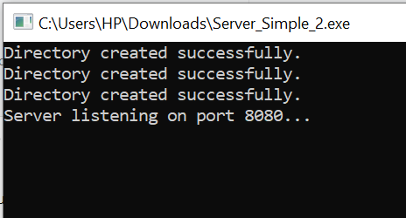
Directory and user details text file created successfully upon running the server script, if directory and file doesn’t already exist:
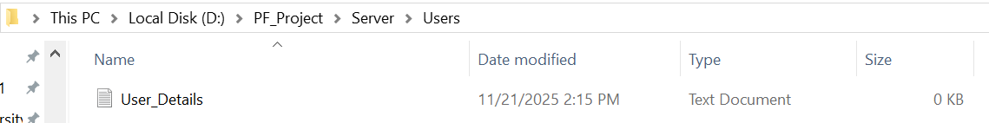

5. Testing & Results
We tested the project on a home Wi-Fi network.
Test No | Input | Expected Output | Actual Output | Status
1 | Login : ”25K0729” ,”pass123” | Login Success | "Login Successful"  Menu Shown To Select Add New Contact / Chat With Existing Users. | ✅
2 | Signup; “25K0610” | Another File Should Be Created | File Updated | ✅
3 | Message To Offline User | Error | “User Offline” | ✅
The program worked for all tests. It handled the data traffic efficiently. The console menu was responsive and validated all inputs correctly.

6. Conclusion, Limitations & References

Conclusion

The LAN Based Chatting System shows how to apply Basic Principles of C language to make a real network tool. By using sockets, we managed to send and receive messages using LAN. This increases encryption and minimizes chances of cyber theft. The project helped us understand arrays, loops, structures, and how to implement router logic in server with Winsock networking.

Limitations
- Messages are sent by terminating the connection of user and server then establishing connection between Friend and Server, which takes time.
- Time taking due to repeated connection handshakes.
- We cannot send images right now, only text.

Future Enhancements
- Multiple Client handling at once.
- Once the connection is established there is no need of terminating it to proceed another message.
- Add a scroll bar to the chat history.

References
- Let Us C by Yashavant P. Kanetkar
- https://www.programiz.com/c-programming
- https://www.geeksforgeeks.org/c-programming-language/

